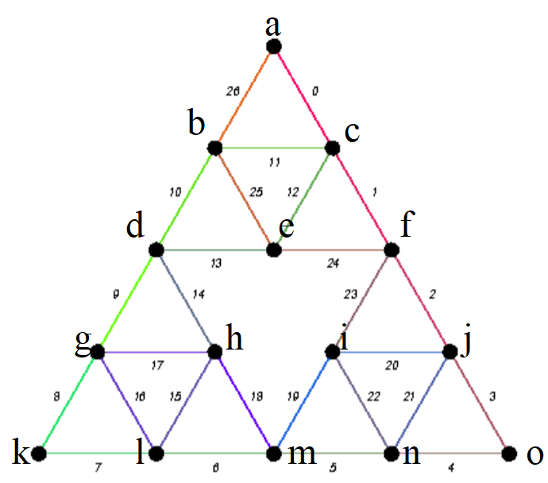

SAU – Ayrık İşlemsel Yapılar  
7. Etkinlik

Onur Osman Güle – G171210021 – 2A

Yukarıdaki graf için Euler halkası ya da yolu hakkında karar veriniz, varsa Euler halkası algoritması ile analizini yapınız.

|  |
| --- |
|  |

a düğümünden başlayıp tüm kenarlardan bir kez dolaşarak tekrardan a düğümüne geri dönülen bir yol bulunduğu için Euler halkası vardır.

|  |  |  |  |  |
| --- | --- | --- | --- | --- |
| E | A | B | P | C |
| 0,1,2,3,4,5,6,7,8,9,10,11,12,13,14,15,16,17,18,19,20,21,22,23,24,25,26 | a | a | a | a |
| 1,2,3,4,5,6,7,8,9,10,11,12,13,14,15,16,17,18,19,20,21,22,23,24,25,26 | a | c | a0c | a |
| 2,3,4,5,6,7,8,9,10,11,12,13,14,15,16,17,18,19,20,21,22,23,24,25,26 | a | f | a0c1f | a |
| 3,4,5,6,7,8,9,10,11,12,13,14,15,16,17,18,19,20,21,22,23,24,25,26 | a | j | a0c1f2j | a |
| 4,5,6,7,8,9,10,11,12,13,14,15,16,17,18,19,20,21,22,23,24,25,26 | a | o | a0c1f2j3o | a |
| 5,6,7,8,9,10,11,12,13,14,15,16,17,18,19,20,21,22,23,24,25,26 | a | n | a0c1f2j3o4n | a |
| 6,7,8,9,10,11,12,13,14,15,16,17,18,19,20,21,22,23,24,25,26 | a | m | a0c1f2j3o4n5m | a |
| 7,8,9,10,11,12,13,14,15,16,17,18,19,20,21,22,23,24,25,26 | a | l | a0c1f2j3o4n5m6l | a |
| 8,9,10,11,12,13,14,15,16,17,18,19,20,21,22,23,24,25,26 | a | k | a0c1f2j3o4n5m6l7k | a |
| 9,10,11,12,13,14,15,16,17,18,19,20,21,22,23,24,25,26 | a | g | a0c1f2j3o4n5m6l7k8g | a |
| 10,11,12,13,14,15,16,17,18,19,20,21,22,23,24,25,26 | a | d | a0c1f2j3o4n5m6l7k8g9d | a |
| 11,12,13,14,15,16,17,18,19,20,21,22,23,24,25,26 | a | b | a0c1f2j3o4n5m6l7k8g9d10b | a |
| 12,13,14,15,16,17,18,19,20,21,22,23,24,25,26 | a | c | a0c1f2j3o4n5m6l7k8g9d10b11c | a |
| 13,14,15,16,17,18,19,20,21,22,23,24,25,26 | a | e | a0c1f2j3o4n5m6l7k8g9d10b11c12e | a |
| 14,15,16,17,18,19,20,21,22,23,24,25,26 | a | d | a0c1f2j3o4n5m6l7k8g9d10b11c12e13d | a |
| 15,16,17,18,19,20,21,22,23,24,25,26 | a | h | a0c1f2j3o4n5m6l7k8g9d10b11c12e13d14h | a |
| 16,17,18,19,20,21,22,23,24,25,26 | a | l | a0c1f2j3o4n5m6l7k8g9d10b11c12e13d14h15l | a |
| 17,18,19,20,21,22,23,24,25,26 | a | g | a0c1f2j3o4n5m6l7k8g9d10b11c12e13d14h15l16g | a |
| 18,19,20,21,22,23,24,25,26 | a | h | a0c1f2j3o4n5m6l7k8g9d10b11c12e13d14h15l16g17h | a |
| 19,20,21,22,23,24,25,26 | a | m | a0c1f2j3o4n5m6l7k8g9d10b11c12e13d14h15l16g17h18m | a |
| 20,21,22,23,24,25,26 | a | i | a0c1f2j3o4n5m6l7k8g9d10b11c12e13d14h15l16g17h18m19i | a |
| 21,22,23,24,25,26 | a | j | a0c1f2j3o4n5m6l7k8g9d10b11c12e13d14h15l16g17h18m19i20j | a |
| 22,23,24,25,26 | a | n | a0c1f2j3o4n5m6l7k8g9d10b11c12e13d14h15l16g17h18m19i20j21n | a |
| 23,24,25,26 | a | i | a0c1f2j3o4n5m6l7k8g9d10b11c12e13d14h15l16g17h18m19i20j21n22i | a |
| 24,25,26 | a | f | a0c1f2j3o4n5m6l7k8g9d10b11c12e13d14h15l16g17h18m19i20j21n22i23f | a |
| 25,26 | a | e | a0c1f2j3o4n5m6l7k8g9d10b11c12e13d14h15l16g17h18m19i20j21n22i23f24e | a |
| 26 | a | b | a0c1f2j3o4n5m6l7k8g9d10b11c12e13d14h15l16g17h18m19i20j21n22i23f24e25b | a |
| Ø | a | a | a0c1f2j3o4n5m6l7k8g9d10b11c12e13d14h15l16g17h18m19i20j21n22i23f24e25b26a | a |
| Ø | a | a | a0c1f2j3o4n5m6l7k8g9d10b11c12e13d14h15l16g17h18m19i20j21n22i23f24e25b26a | a0c1f2j3o4n5m6l7k8g9d10b11c12e13d14h15l16g17h18m19i20j21n22i23f24e25b26a |

Algoritmanın sonunda  
 C = a0c1f2j3o4n5m6l7k8g9d10b11c12e13d14h15l16g17h18m19i20j21n22i23f24e25b26a   
olur.  
Yolumuz ise a-c-f-j-o-n-m-l-k-g-d-b-c-e-d-h-l-g-h-m-i-j-n-i-f-e-b-a.

SAU – Ayrık İşlemsel Yapılar  
7. Etkinlik

Onur Osman Güle – G171210021 – 2A